This is to improve my understanding of part of the problem (related to access to water) that we are trying to solve

In <https://www.icrc.org/en/doc/assets/files/other/icrc_002_0998.pdf> it is stated that though shallow dug wells are cheaper to setup those get contaminated easily; that may not be true with water lifted using borehole (implies less or no treatment is required to bring the water to desired quality before using) and the water level may not drop significantly due to limited rainfall/during drought. (I do not claim it is the best article but it is explaining concepts in a way that a non hydrologist like me can easily understand. Also I shall look for more resources).

1. Location of untapped aquifers

*** additionally “Borehole that can exploit more than one aquifers” —- how to find that type of location out?

Which one would produce large yields.

Need to research

Type (mechanical, electrical) of pump possible/needed (?).

1. Source/location of high contamination
2. Access to labour /transportation (of materials to dig hole) at a reasonable cost

Site monitoring/maintenance cost

We may want to collect data and make overlapping maps of the above (A, B, C) to figure out suitable location for having borehole.

<http://theconversation.com/how-nigeria-is-wasting-its-rich-water-resources-83110>

<http://www.unesco.org/new/fileadmin/MULTIMEDIA/FIELD/Nairobi/nigeria.pdf>

### **Groundwater quality information Nigeria** <https://pdfs.semanticscholar.org/1ad0/3d086a504ea3052b2075e1c72ae593081e24.pdf>

Added by Michal:

Under the link is a document describing process of drilling boreholes. Interesting pages 10, 14, 15, and much more :wink: . [https://www.unicef.org/wash/files/04.pdf](https://slack-redir.net/link?url=https%3A%2F%2Fwww.unicef.org%2Fwash%2Ffiles%2F04.pdf)

Added by Michal:

First article addresses directly our problem. [http://nah-nigeria.org/#/journal-details/Water_Resourses_Volume_29](https://slack-redir.net/link?url=http%3A%2F%2Fnah-nigeria.org%2F%23%2Fjournal-details%2FWater_Resourses_Volume_29)

[**Shubham Bindal**](https://app.slack.com/team/UPTCMMHQR) [6:18 AM](https://omdenarenewab-fcd1248.slack.com/archives/CQC0THELX/p1573481890014100) (Nov 11, 2019) (from Slack)

Digital groundwater maps of Africa

<https://www.bgs.ac.uk/research/groundwater/international/africanGroundwater/mapsDownload.html>

and research done by NASA related to this problem :

[https://agupubs.onlinelibrary.wiley.com/doi/epdf/10.1002/2015WR017349](https://slack-redir.net/link?url=https%3A%2F%2Fagupubs.onlinelibrary.wiley.com%2Fdoi%2Fepdf%2F10.1002%2F2015WR017349)

[**Yacine HADDAM**](https://app.slack.com/team/UPQ9TA19R) [9:46 AM](https://omdenarenewab-fcd1248.slack.com/archives/CQC0THELX/p1573494371017300) (Nov 11, 2019) (from Slack)

“I am trying to construct a map of moisture of soil based on satellite images and then i will create a simple model to represent the relationship btw soil moisture and groundwater. I think , i will have the first insights in two days

<https://www.nrcresearchpress.com/doi/pdf/10.4141/cjss10044>”

**Trello Task: Water Supply**

Data (did not assess whether it is best or not yet and did not do any data validation)

As of now would like to use the groundwater map from uk geological survey. We can use two maps from UK geological surveys - one is Ng groundwater storage and another is Ng groundwater depth

Under the Trello task “Water Supply” Himadri posted “what is the best depth to use?”

Why does depth matter?

The depth is important as evident from @Mical W’s posted link on Slack: <https://www.unicef.org/wash/files/04.pdf>

It says if the groundwater is at a large depth then machine drilling is required which has at least 4 times more cost than shallow hand drilling (of at most 35 m depth) as for example. Machine drilling may be very pricey for the community under consideration.

* How about during the first phase of the analysis we target the aquifers at most at 35 m depth to create a framework for solving this and then gradually as we iterate we can look at machine drilling options where it is easier and relatively cheaper to get one … may be due to less distance to travel after renting such machines).

It is also worth checking how many of the aquifers within 35 m from surface level have good enough volume of water.

The data from UK GS can be good for ML step after categorical encoding

Update: As I try to load and convert the txt/ascii file using qgis using combination of ideas from here <https://gis.stackexchange.com/questions/17607/manipulating-ascii-asc-files-in-qgis> and the input type as delimited text file … the data was loaded in QGIS and map is visible, looks like the following but it is is not looking right

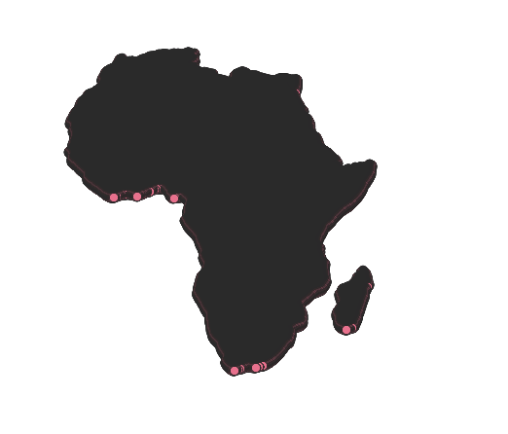

Would try data from different source as the above did not go well for me.

Looking at data from FAO now

Some glossaries and metadata

<http://bit.ly/2QMxCU7>

<http://www.fao.org/nr/water/aquamaps/>

Also need to take out ( from consideration

) what ground water source is already in use.

<https://www.un-igrac.org/special-project/africa-groundwater-portal>

<https://apps.geodan.nl/igrac/ggis-viewer/viewer/go/public/default>

“'Water abstraction' refers to the process of taking or extracting water from a natural source (rivers, lakes, groundwater aquifers, etc.) for various uses, from drinking to irrigation, treatment, and industrial applications.”

<https://www.gsi.ie/en-ie/programmes-and-projects/groundwater/activities/understanding-ireland-groundwater/aquifer-classification/Pages/Aquifer-categories-and-types.aspx>

<https://wle.cgiar.org/content/transboundary-aquifer-map-africa>

<https://nerc.ukri.org/research/funded/programmes/upgro/20140513-africa-groundwater-atlas/>

Some documentation explaining concepts used in BGS:

<http://nora.nerc.ac.uk/id/eprint/515821/1/OR16046.pdf>

<https://docs.qgis.org/2.8/en/docs/user_manual/working_with_vector/supported_data.html>

Have to clip only Nigeria from it. However the whole Africa groundwater map from BGS looks like this with M, H, VH water storage filter added to the layer as we load the ascii file in QGIS

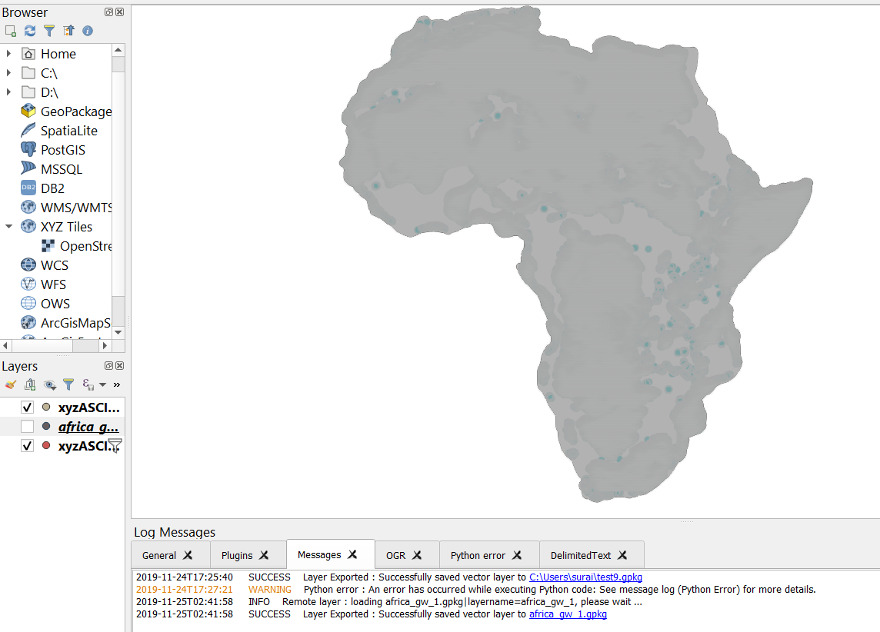

Started seeing things after setting up layer transparency (with that setting layer is no longer not 100% opaque) <https://gis.stackexchange.com/questions/101645/qgis-still-not-rendering-wms-layers/101668>

<https://www.pseau.org/outils/ouvrages/ucl_mapping_the_groundwater_vulnerability_for_pollution_at_the_pan_african_scale_2015.pdf>

QGIS:

<https://www.lutraconsulting.co.uk/blog/2014/06/06/getting-started-with-qgis/>

<https://groups.nceas.ucsb.edu/trn/protocols-and-instructions/Getting_started_with_qGIS2.doc/at_download/file>

<http://www.stedmundsburychronicle.co.uk/qgismaps/data.htm> talks about how to clip the portion that we want

<https://csisa.org/wp-content/uploads/sites/2/2018/04/QGIS_CSISA_2018.pdf>

(page 61-64)

<http://www.freewat.eu/>

<https://www.hatarilabs.com/ih-en/tutorial-for-the-installation-of-freewat-the-modflow-interface-in-qgis>

<https://www.sciencedirect.com/science/article/pii/S1364815217309453>

<http://earthwise.bgs.ac.uk/index.php/Hydrogeology_of_Nigeria#Groundwater_quantity>

<http://earthwise.bgs.ac.uk/index.php/Hydrogeology_of_Nigeria> there are downloadable shp files here (several) on this page - I downloaded one pkg from there.

Is the granularity (area level) as available in the files in the pkg good enough for us?

Q: Do we care about groundwater where there is a supply of surface water?

How to convert ESRI lyr file to be able to load it in QGIS? - for now can ignore … the category and classify option (described below) served my purpose that I was trying to accomplish or get from lyr.

https://gis.stackexchange.com/a/317014

<https://www.reddit.com/r/gis/comments/37lfoa/symbology_conversion_is_lyr_to_qlr_possible/>

This is nigerian hydrology data (I downloaded from here: <http://earthwise.bgs.ac.uk/index.php/Hydrogeology_of_Nigeria> )

n/a means surface water

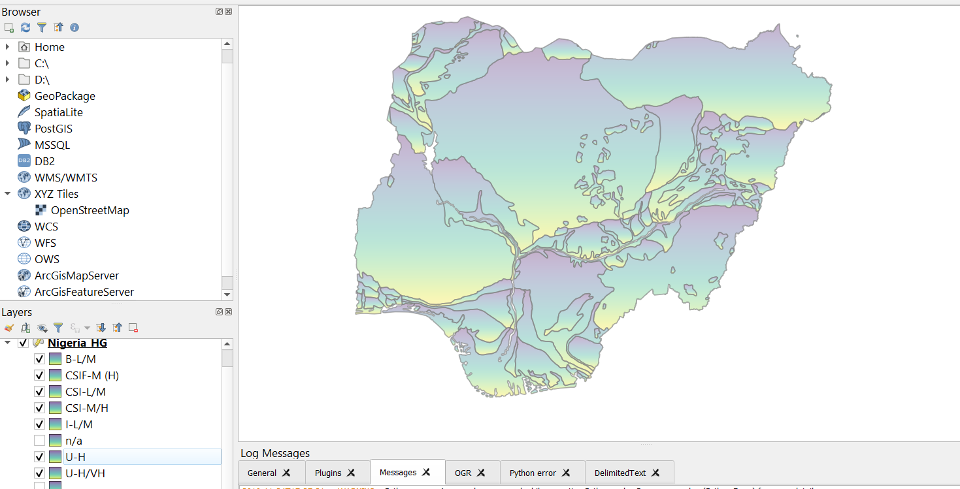

Able to see this after loading shape file and then right clicking on the layer from bottom left panel ; then in the style menu that appears select category instead of simple …

Then from the column select the second one (followed instructions from page 45 of <https://csisa.org/wp-content/uploads/sites/2/2018/04/QGIS_CSISA_2018.pdf>)